Twinkl Go-
Twinkl Go has lots of fantastic games!
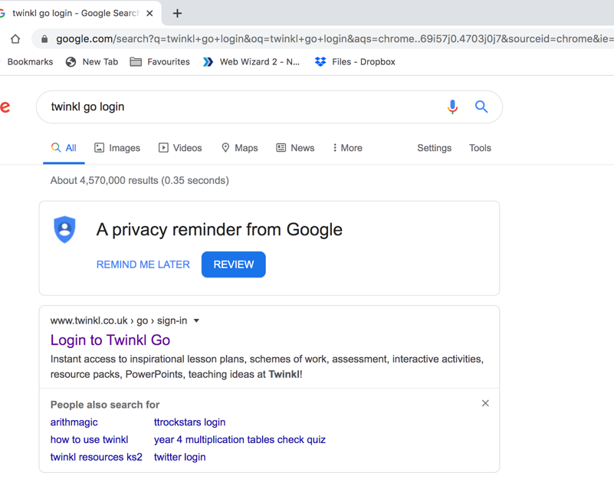

Google “Twinkl go login”

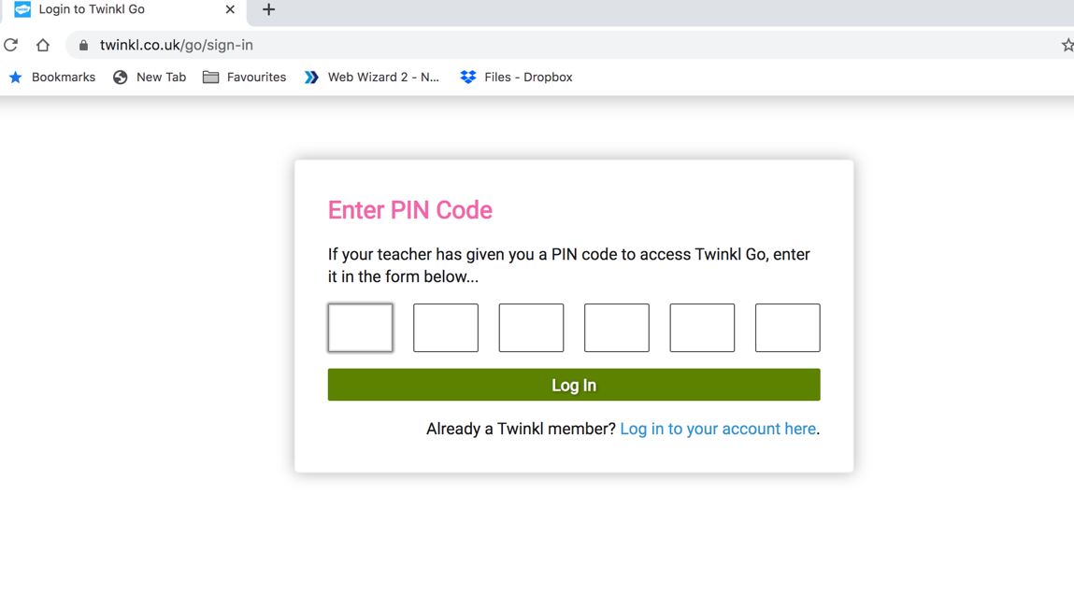

This screen should appear. Enter the following pin code:
Reception: CM6923
KS1: CM0317
KS2: CM5941

A screen with a game on it should then appear (this is the reception one):
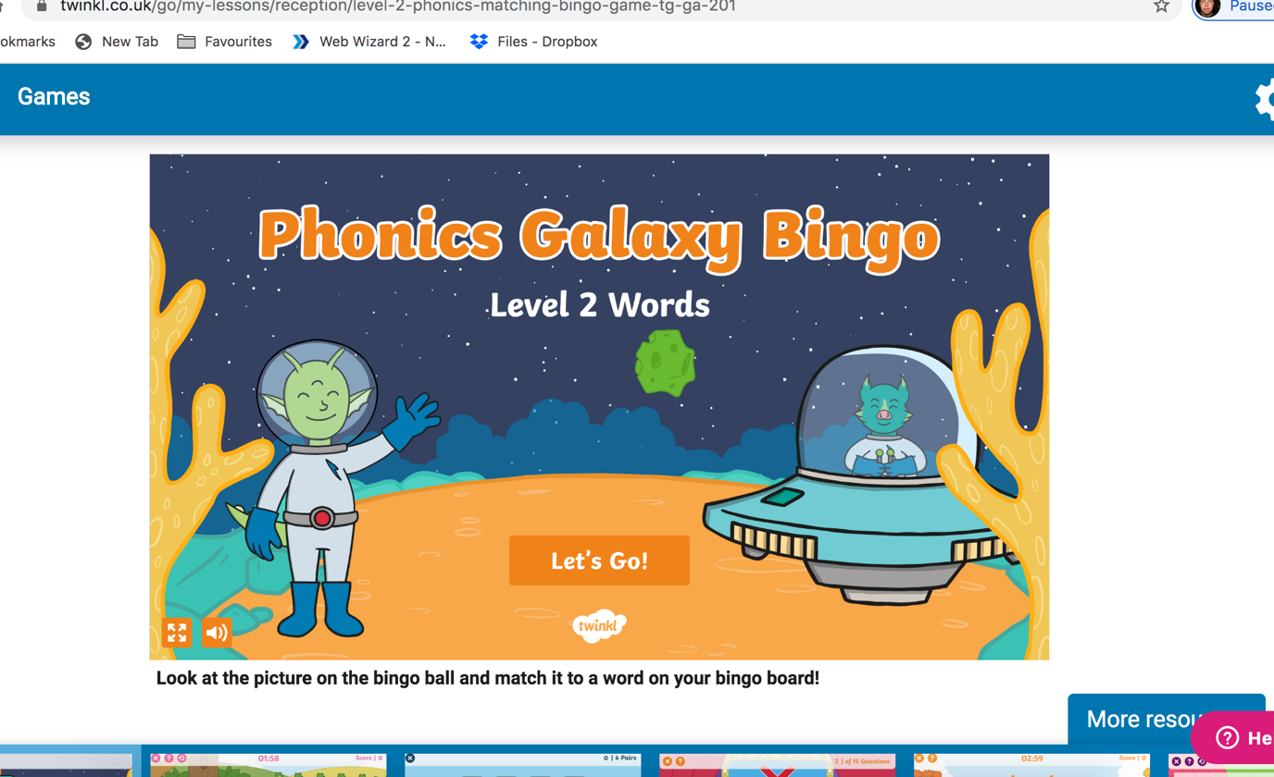

Click on “more resources” to see more games.

